Ranoa, Julius

CSC 121 001 Computer Science I

28 September 2017 Thursday

**Quiz 5**

**Modification of Home Software Company OOP Case Study (Program 7-17)**

The source code below has been modified to report withdrawal and deposit transactions separately. Modified parts are highlighted in yellow.

Screenshots of Runtime:

*Note that the screenshots are truncated to only display the last parts of the output.*

(1) 5 Total Transactions (2) No withdrawals (3) One failed withdrawal

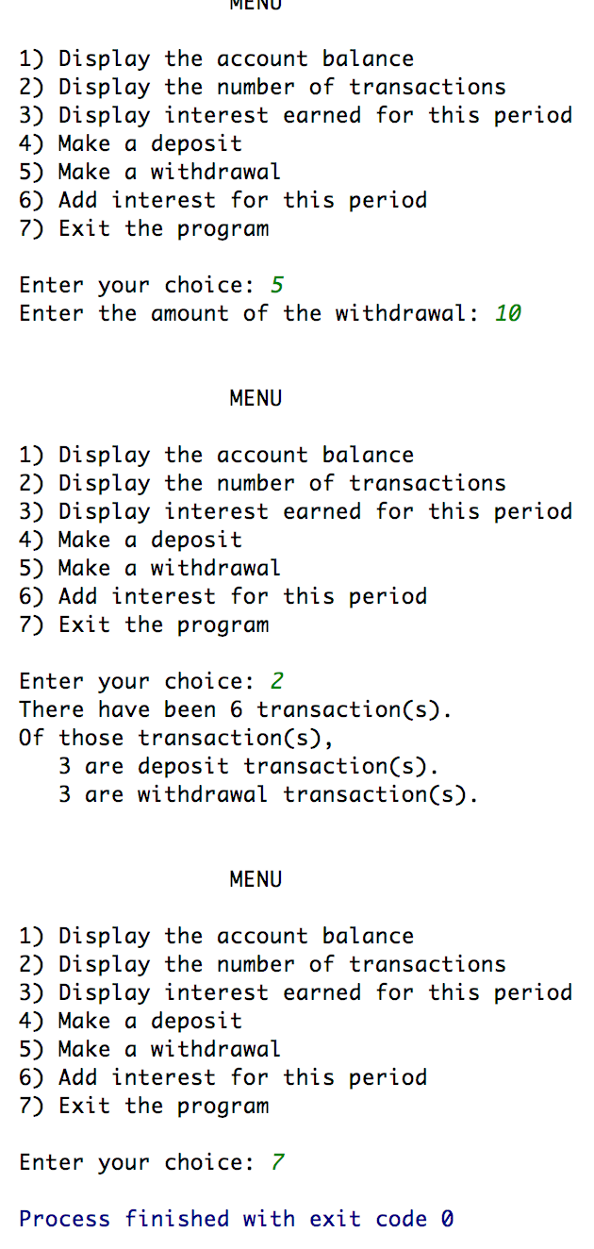 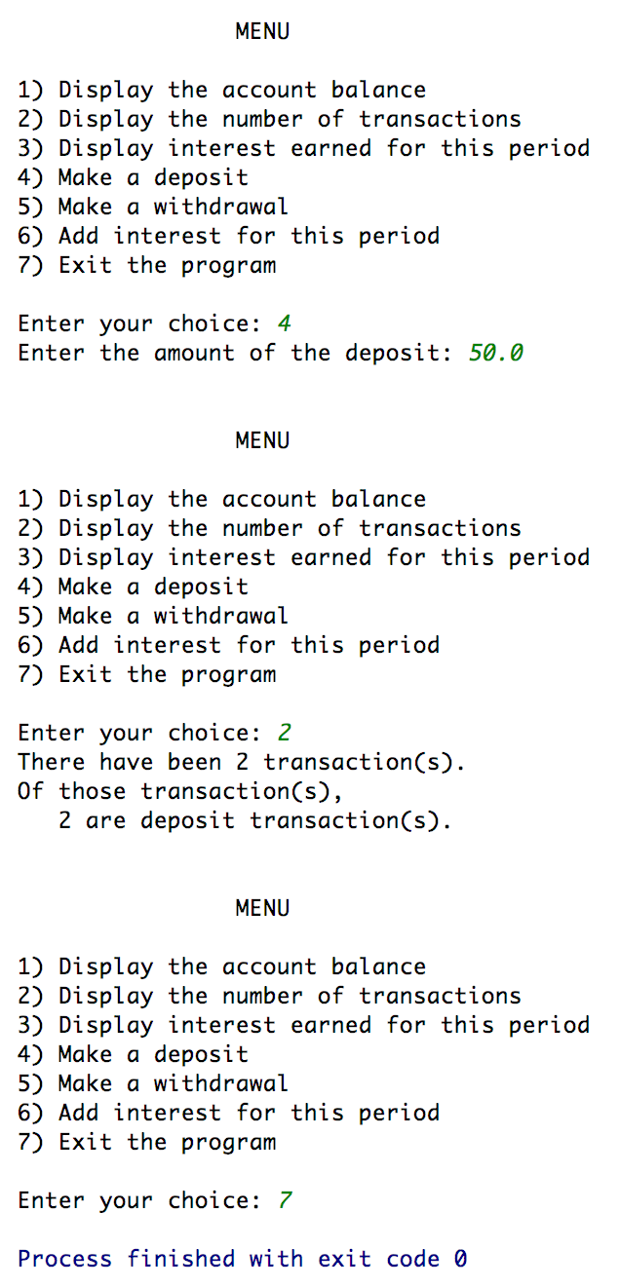 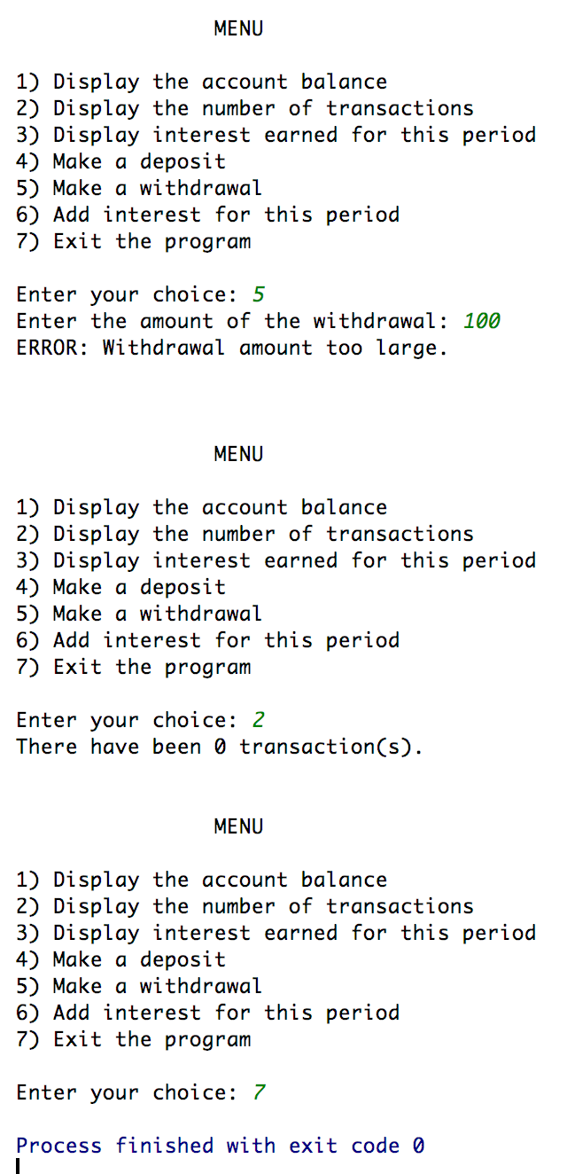

Source Code:

The following files are included in the project.

* Account.h
* Account.cpp
* main.cpp

Project files are also posted in GitHub.

<https://github.com/TheLoneWoof1102/FA17_CSC121001/tree/master/Source%20Code/Sandbox-Wk6.Ch7-8>

**Account.h**



***End-of-File: Account.h***

**Account.cpp**



***End-of-File: Account.cpp***

**main.cpp  
*1 out of 3 pages.***



***main.cpp is continued next page.***

***cont’d – main.cpp***



***main.cpp is continued next page.***

***cont’d – main.cpp***



***End-of-File: Account.cpp***